SAVE THE DATE
MGCCQ – DARLING DOWNS
ALL CHAPTER GATHERING
TOOWOOMBA - 23rd to 26th AUGUST 2024
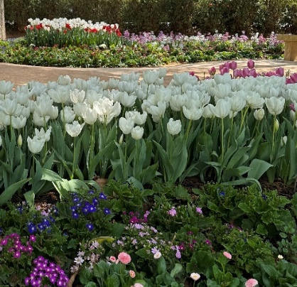
We invite you to join us in our beautiful city of Toowoomba for the MGCCQ All Chapter Gathering in 2024. The programme will be as follows:
- Friday evening – Registration, Noggin N’ Natter at Picnic Point
- Saturday - Your choice of 1 of 4 guided Kimber Runs around the Toowoomba region
- Sunday morning - Show & Shine at Cobb & Co Museum
- Sunday afternoon - Your choice of self-guided runs throughout the city.
- A formal dinner will be held in the evening at Picnic Point. Themed “Flower Power”
- Monday – Farewell breakfast at Cobb & Co Museum
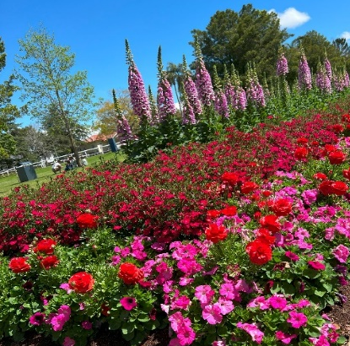
A list of accommodation has been provided to your Chapter Co-ordinator. This is a very busy period for Toowoomba, as the Carnival of Flowers commences 1st September and continues for the entire month. Accommodation bookings MUST BE MADE NOW to ensure availability. Registration for this event will be available in March, 2024.
Please direct any enquiries to ddc.mgccq@mgccq.org.au

