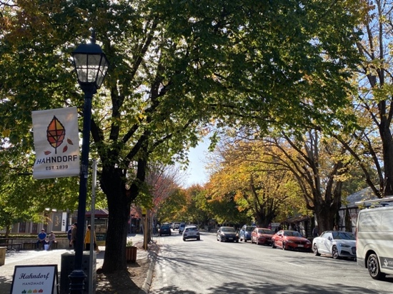

**2026 MG NATIONAL MEETING – HAHNDORF**

**Monday 27 April – Friday 1 May (NOT Easter)**

***June 2025 Bulletin***

Greetings to all MG owners and drivers across Australia with the great news that expressions of interest for the 2026 MG National Meeting at wonderful Hahndorf, South Australia are now open.

You can register your interest by contacting Chris Bray, her email address for this is [registrar2026natmeet@outlook.com](mailto:registrar2026natmeet@outlook.com)

The event website is up and running at **2026mgnationalmeeting.com.au** and is being regularly updated as more details and info come to hand.

Our base will be the Adelaide Hills Convention Centre (AHCC) run by Discovery Events. This is the venue and/or starting point for many events on the program and offers a great range of accommodation – though at the time of writing this, about three-quarters of the rooms are already booked out. To make a booking phone Sarah on (08) 8388 7921 and she will be happy to take your details. Please do NOT try to book online.

Their website <https://discoveryevents.com.au/venues/adelaide-hills-convention-centre> includes details and pictures of the different types of accommodation available.

Hahndorf offers many other accommodation options and attractions and you can find details at the usual places such as Booking.com, Tripadvisor, Wotif etc.

Next year’s program is:

* Monday 27th April – Registration; Noggin’n’Natter / Rocker Cover Race all at AHCC
* Tuesday 28th April – Concours at Oakbank Racecourse; Theme Party at AHCC
* Wednesday 29th April – Motorkhana at The Bend Motorsport Park or Social Kimber Run leaving from AHCC and finishing at The Tavern on Hindmarsh Island.
* Thursday 30th April – Super Sprint at The Bend Motorsport Park or Discovery Run finishing at Murray Bridge; Formal Dinner at AHCC
* Friday 1st May – Farewell Breakfast and Delegate’s Meeting at AHCC.

The Bend Motorsport Park at Tailem Bend is less than an hour away from Hahndorf on National Highway M1.

Apart from Hahndorf itself, here are a couple of other attractions to entice you.

The Oakbank Racecourse, which will be the Concours venue, is nestled amongst the leafy green landscapes of the Adelaide Hills, only a few minutes’ drive from Hahndorf and 30 minutes from the Adelaide CBD. Its picturesque views, historic importance and well-kept grounds are the major drawcards for thousands of tourists each year. The Concours will be in a great area with shade, seating and other facilities, and a pleasant stroll from the main street of Oakbank where you will find various food and drink options.

Even closer is the unique Karkoo Nursery, spanning three acres filled with thousands of ever-changing products including plants, pots, garden art, antique finds, a clothing boutique and home/gift store set amongst beautiful historic buildings. Karkoo offers daily dining with a 150-seat licensed Garden Kitchen in what were the original horse stables.

Oakbank’s attractions are sure to make your Concours day very special.

Please direct any general queries about the 2026 MG National Meeting to Tim Edmonds at [Chairman2026natmeet@outlook.com](mailto:Chairman2026natmeet@outlook.com)

We’re looking forward to seeing all our MG friends next year!!