
MGCC of Qld Inc., Capricorn Chapter
You’re invited to our 2023 CHRISTMAS PARTY!

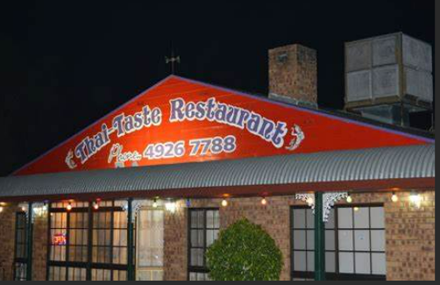
Please, come along and celebrate the end of 2023 with a night of good company, friendly chatter and generally, to have a nice relaxing evening.
Where: THAI TASTE,
635 Norman Road Norman Gardens
When: Friday 1st December, 5:00pm - till late
Dress: Smart Casual, wear your MG regalia or your favourite Christmas gear
Cost: $35:00 per person, must be paid prior to evening, payment is due 7 days prior to event. Bank transfer to Jim Armstrong (Capricorn Chapter’s account) preferred or cash.
BSB 014760 Account number 644378471 Please ensure that you leave your name in the reference box on the bank payment form.

N.B if you cancel less than 24hrs before the event or don’t turn up on the night, then I am sorry your money cannot be refunded. The 24hr period is the latest we need to notify Thai Taste.
R.S.V.P by Friday 24th November, to Jim, Clare, Jo or Phil
This years’ dinner will be a quality Thai Taste Banquet, an array of entrees Spring rolls, Satay chicken sticks and Money bags.
The mains will be plates of Red Curry with beef, Green Curry with chicken, Fried Rice with pork, Cashew Nut Stir-Fry with chicken, Sweet and Sour Stir Fry with Pork and an offering of Jasmine Rice and Coconut Rice.
Please advise ASAP if you have special dietary needs.
Drinks are at your expense and not included in the cost.
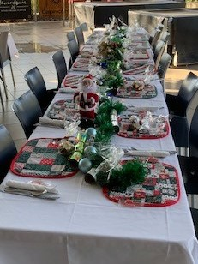
For a bit of fun as it worked so well last year SECRET SANTA is back, maximum $10 spend. One Secret Santa present per person, if you want to take a pressie please bring one wrapped and we will place it under the tree for after dinner.
NB: If you know of a genuine potential member/s (either restoring or recently purchased an MG or similar) please invite them along, they will be welcomed, however they will be liable for their own meal costs.
Chapter Coordinator: Jim Armstrong Ph 0417 544 222


Run Committee: Clare Lynam Ph 0448 752 633
Jo Emmert Ph 0448 071 526
Phil Henry Ph 0434 017 132.

