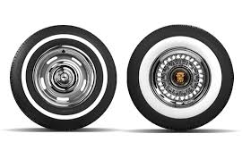
KNOW YOUR TYRES - CLASSIC CARS

by Rod Graydon – Automarine Consulting

Many classic and vintage vehicles are often stored for long periods and only taken out for special events including classic car rallies and displays or the occasional trip around the block. Whilst owners may check the oil and water and wash and polish their pride and joy the inspection of tyres is often a quick glance and or pressure check but here lies a common situation. Tyres that don't travel a great distance often look good by having good tread depth etc but could be well and truly aged and this may cause deterioration in the tyre and subsequent issues with the vehicle's safety should the tyre fail.

Below is a guide for you as owners of classic cars to use so that you' Know Your Tyres'

TYRE PRESSURES

Tyre pressures should be checked monthly and before commencing any driving. Tyre pressures vary from vehicle to vehicle to tyre to tyre. The maximum tyre pressure printed on the side of a tyre is not what they should be set at. The weight of the vehicle in general use needs to be considered against the maximum psi for the tyre relating to the load rating of the tyre.

NOTE:- The recommended tyre pressures will be cold pressure checks. If checking after any driving always add 4psi to the recommended pressures for radial tyres.

Take into account the following when calculating tyre pressures.
. Passenger vehicles with radial tyres generally run between 30 to 40 psi depending on the vehicle and loading:- (most operate between 32 and 36psi)
Older cast iron engines with their weight require higher pressure in the front especially if no power steering is fitted. If you swap to a later model engine with alloy head (lighter weight ) then a lower pressure may be adopted.
. Always increase the pressure in the rear tyres if towing or carrying large weight or a full capacity of passengers.

The old habit of kicking a tyre to ensure it is inflated may have been the norm in days gone by but not any more.

A quality tyre pressure gauge is an essential tool for any vehicle as tyre gauges at service stations, particularly the old style hand gauge cannot be considered as an accurate measurement on all occasions.
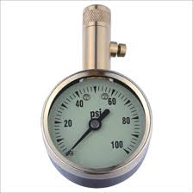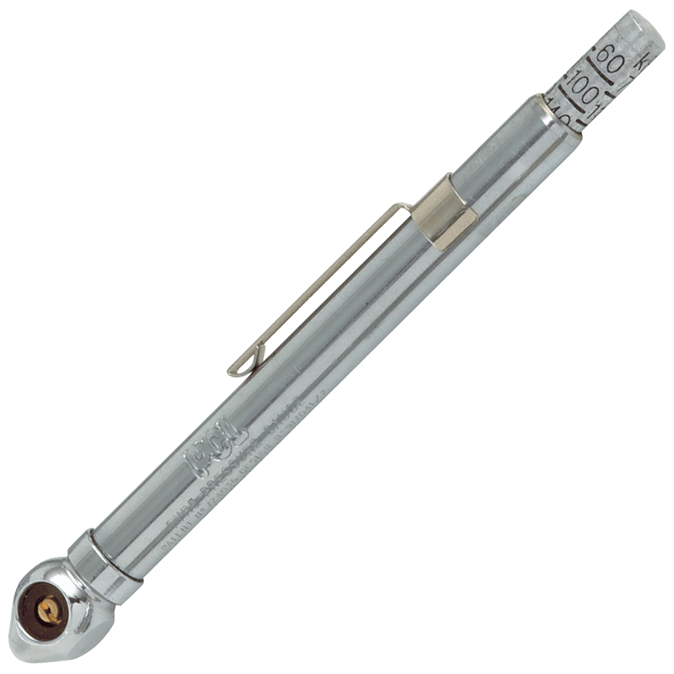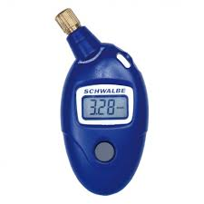

Cars manufactured since the 1970s may have had a tyre placard attached to the body or interior. (sticker or plate). This will contain details of the original tyre sizes plus recommended tyre pressures.

Original car handbooks or manuals may also contain details on tyre pressures BUT BEWARE !
The recommended pressures from ‘back then’ may be higher than appropriate now as they relate to original size tyres of original manufacture style, construction and technology. I.e. cross ply or textile radials. Tyres of today will generally run pressures less than tyres of yesteryear due to the material components used in the manufacture of current tyres against straight carbon black tyres of the past.

Always consult your local tyre dealer and or other club members with similar vehicles to gauge the right pressures for your vehicle and driving situations.

Tyre Pressures often drop over a period of time but 'Leaky' tyres may be a sign that that:-

. The rim has dirt and or bead lube (used when fitting the tyres) or corrosion around the lip of the rim where it meets the bead.(especially on older alloy wheels)
. The valve core is leaking- tighten or replace and ensure a tight fitting valve cap is applied.
. The rubber valve itself is cut or has deteriorated
. An internal tube is leaking.
. The tyre has a puncture or is cracked and may have a minute split.
. The bead of the tyre is damaged.
. A clip on wheel weight may not be seated right and causing a leak there.

Checking for Leaks:- Inflate the tyre and using a hose run a steady flow of water around both the front and back beads of the tyre. A leak will be identified by a bubbling of the water by the air exiting the tyre. Mark this spot with chalk and have your tyre dealer remove the tyre and identify the actual cause of the leak there.

SPECIAL NOTE RE TUBES

It is imperative when fitting a new tube that the inside of the tyre is completely clean, especially removing any small date or code stickers affixed to the inside of a tyre. The constant rubbing of a tube on one of these stickers may cause a hole in the tube. Talcum powder is a good assistant to use when fitting tubes and reduce harsh rubbing between the tube and the tyre.

Ensure the valve is the correct size for the hole in the rim. A lot of old cars have a larger than normal valve hole. In the case of a tube with a standard TR13 valve it is necessary to fit a plastic feral around the valve to prevent excessive movement of the valve against the metal edge of the rim.

Steel rims fitted with tubes often allow a small amount of moisture to enter and circulate inside the tyre thus causing rust and corrosion to the inside of the wheel. Take the time to clean up the rim with a wire brush and then apply a good quality paint such as kill-rust or similar to ensure long term protection.

If you are fitting new tyres and by virtue of your rim and or tyre require tubes fit new tubes at the same time.
Note:- By the nature of some rims you may also require a rust band, especially with wire wheels. Consult your tyre dealer to ensure all these items are fitted.

REMEMBER:- New tyres fitted to a classic or historic car will generally be there long term. Some extra time spent on preparation and application will be good grounding for many years of trouble free motoring.

ASSESSING TYRE AGE

How do I tell the age of a tyre ?

All tyres are produced with a serial Tyre Identification Number (or Serial TIN) that shows the date of manufacture of a tyre (see Figure 1&2 below). The last three digits (for tyres made pre 2000) or last four digits (for post 2000 tyres) of the serial TIN indicate the week and year that the tyre was manufactured. For example, Figure 1 below shows a tyre made in the 37th week of 1995 and Figure 2 shows a tyre made in the 12th week of 2004. Also a tyre manufactured in the 1990's can be distinguished from a tyre manufactured in the 90's by a triangular identification after the last number which is not present on 1980's tyres.
Figure 1: Serial code for 37th week of 1995
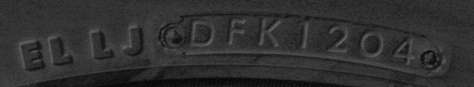Figure 2: Serial code for 12th week of 2004
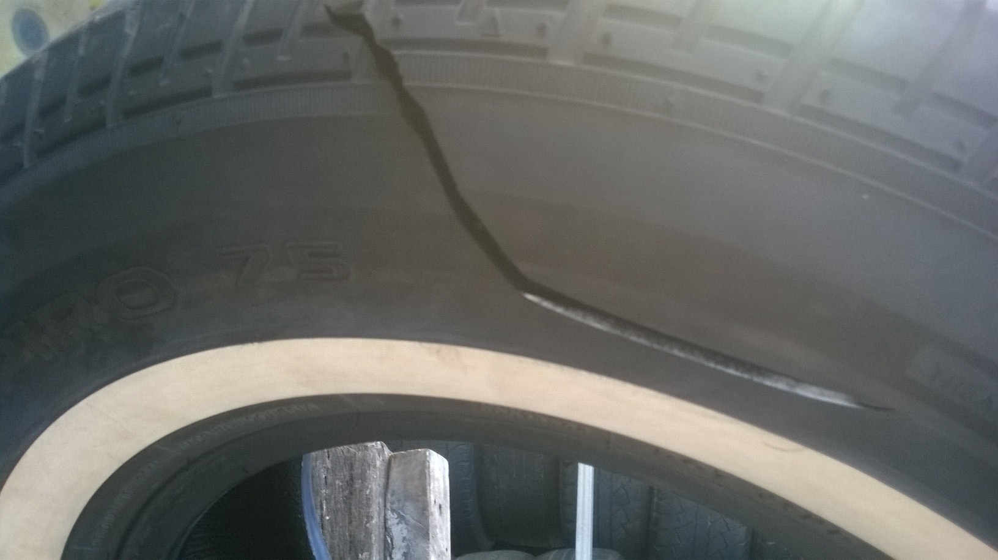
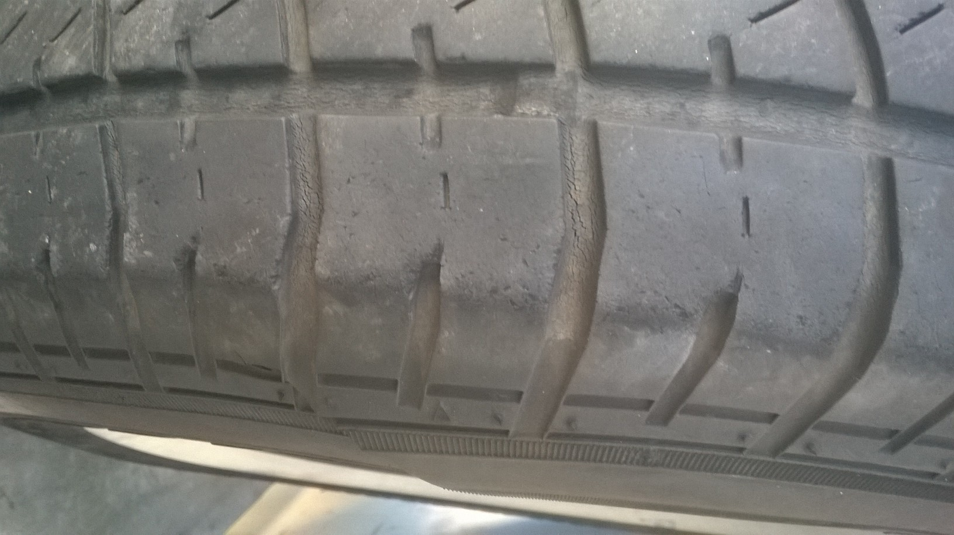
**There is 'NO' legal age for a tyre to be used on a vehicle but extra consideration should be given to tyres over 8 years of age. Check the condition overall of any age with consideration given to replacing any tyre that is cracked or indicates uneven treadwear that may indicate tread separation.
The above tyre was 9 years old and separated the tread which lead to a bubble in the sidewall that burst and caused the split- only a few minutes after I had left the 100 kph zone on the free-way.
Every tyre is individual and requires regular inspection- Not just a kick and ‘she’s ok' attitude

STORAGE OF TYRES

ON VEHICLE

A vehicle being stored for even a few weeks, especially on concrete should be parked on carpet mats with pressures checked monthly. If a vehicle is to be stored for longer periods it is advisable to support the vehicle on axle stands or similar with the wheels off the ground.

If parked in a carport with open sides where the sun may shine in then cover the tyres with a tarp or reflective silver car shade.. This will prevent the sun from shining intensely on one spot of the tyre on a daily basis. Four wheel drive vehicles with rear mounted spare tyres that are parked for long periods in carports with the rear facing out sometimes find the spare tyre has sun damage from continual exposure at the same position on the tyre each day. Spare wheel covers on 4wd vehicles are not just for show, but to protect the tyre.

LOOSE

Any tyre mounted on a rim should be inflated to the recommended pressure when entering storage.
All tyres may be laid flat on the ground or on a shelf and may be stacked on top of each other or upright on a shelf or against a wall proving that
1/ They are stored in a cool environment.
2/ Not stored directly onto concrete.
3/ Not exposed to the sun .
Avoid storing tyres in un-vented garden sheds where temperatures may rise and fall dramatically.

PORTAWALLS AKA WHITE FLAPPERS

These are the white rubber rings you can apply to tyres to give the large white wall effect without the expense of a true white wall classic tyre BUT beware – There are precautions that need to be taken.
Porta walls were designed to be used with cross ply tyres that have a very stiff sidewall. They may also be used with light truck rated tyres that also have stiff sidewalls but it is recommended that you do not use them on normal passenger tyres as the sidewalls of the tyre flex too much which increases the friction from the flapper rubbing against the sidewall of the tyre. Portawalls are stiff when mounted to keep them in shape BUT this means they will move against the tyre and groove the sidewall of your tyre as depicted.

TIPS ON PORTAWALLS
Use only on cross ply or light truck rated tyres
Maintain pressures in the tyres to give a stiffer sidewall
Use rubber grease between the rib and the tyre to reduce friction.
NOTE:_ All Portawalls aka Flappers require a tube to be fitted - even to tubeless tyres.

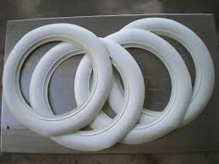
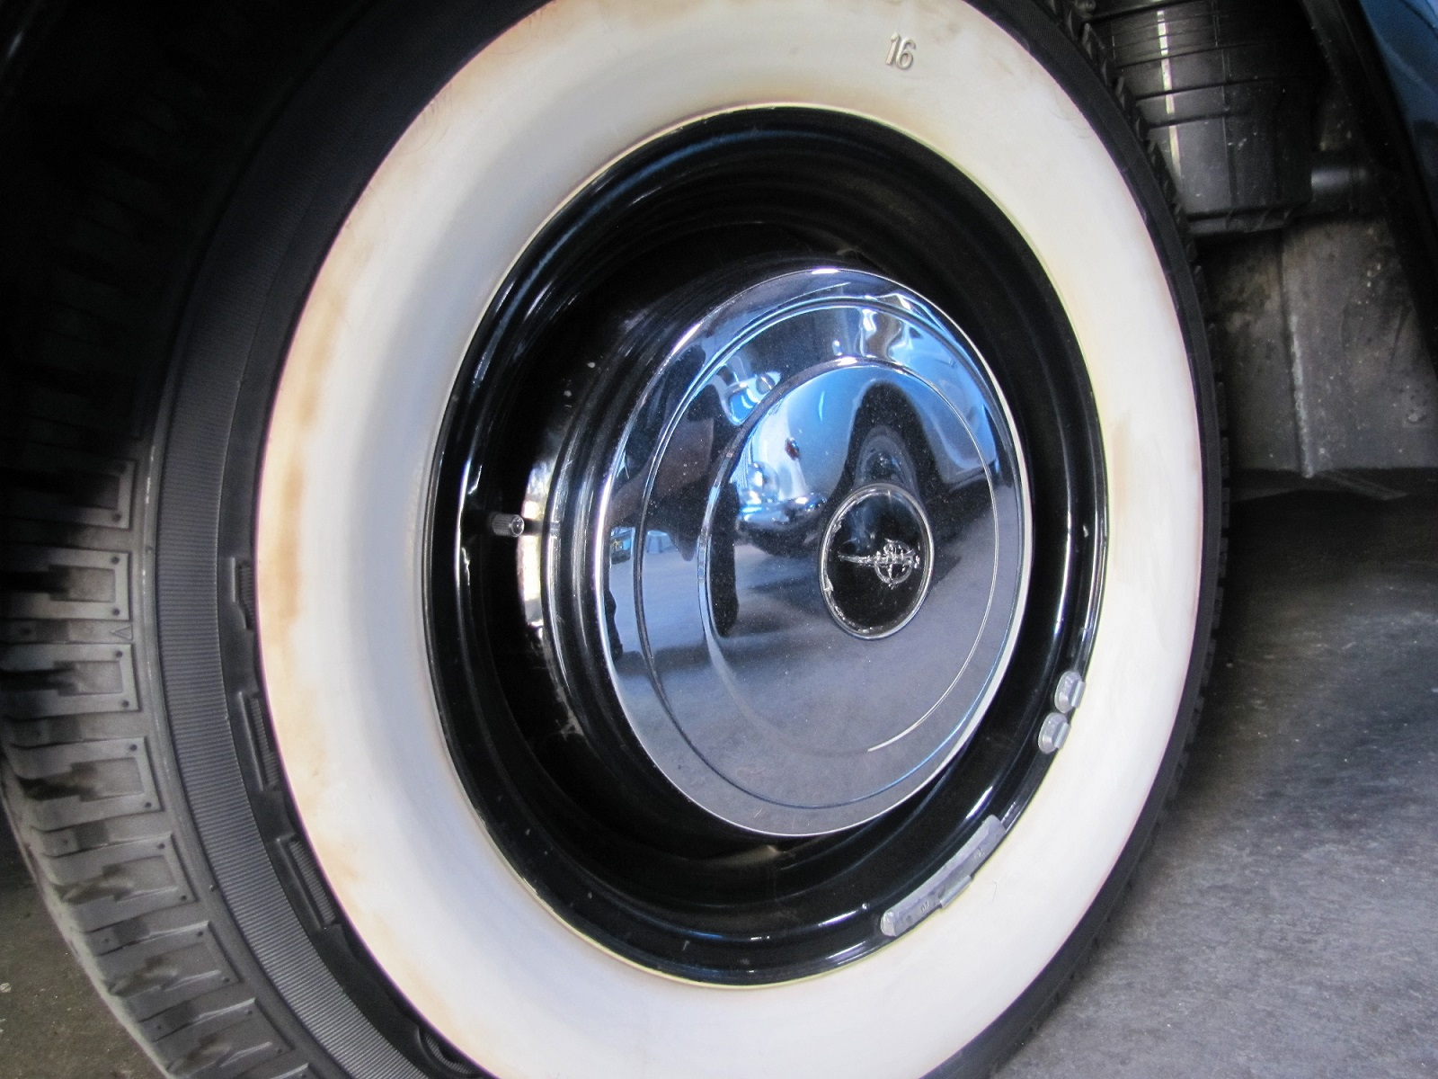
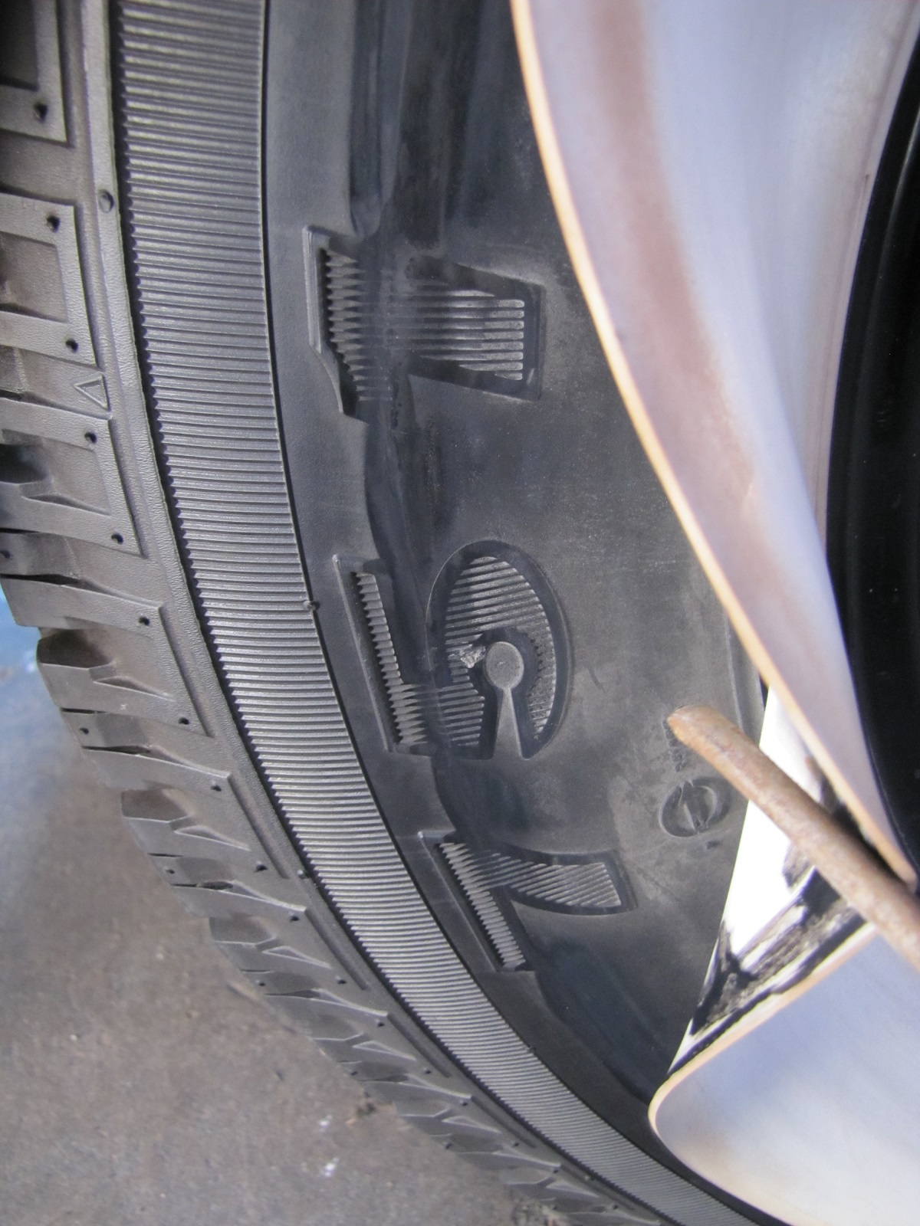

If you suspect a tyre failure when driving you must stop asap but consider the following.

A sudden and constant vibration through the steering wheel and or sudden pulling of the vehicle to one side may indicate a tyre failure is imminent.

1/ Take your foot off the accelerator immediately.
2/ Do Not apply the brakes in a sudden manner. A failing front tyre may under heavy braking cause the vehicle to veer suddenly to the left or right.
3/ Look to the side of the road for a suitable place to pull over immediately.
4/ Attempt to steer the vehicle to a safe parked position with minimal braking and or acceleration.
5/ Allow yourself room to change the tyre .
6/ Use a Safety triangle or cone to Alert other motorists to you being stopped.

When inspecting the tyre adopt the following actions.

1/ Cast a visual inspection of the tyre from no closer than a metre away. If you see a bubble emerging on the side of the tyre then back away further as there is a good possibility this tyre will explode.
2/ Rub your hand around the tread of the tyre and note any abnormal bumps or deformity in the surface.
3/ Be sure to check the surface all the way across and take particular note of any irregularities on the inside shoulder. Vehicles with independent rear suspension are notorious for wearing the inside shoulder of tyres, especially if towing or failure of the rear suspension. A poor wheel alignment (front or rear) could also be the reason for irregular tyre wear.

At the first sign of any sudden vibration from a tyre- Immediately stop the vehicle and change the tyre. Do not try and drive home.

BEFORE YOU DRIVE

. Check your tyre pressures
. Inspect your tyres visually.
. Run your hands regularly around the tyre, especially the inside before heading to check for any deformity..
. Ensure you have a spare tyre the same size as what is fitted to the vehicle.
. Ensure all wheel nuts are tight and that you have a suitable wheel brace, jack, wheel chock and hub cap remover should the need arise.

“A safety triangle or hazard cone are good accessories to carry in your vehicle.”

All tyres, especially unused spare tyres should be inspected periodically to determine their suitability for service. If there is any question as to the condition and or about the tyre's suitability then please consult your local tyre retailer.

DISCLAIMER:- The above information is a 'guide only' to the care and maintenance of tyres fitted to classic vehicles. Tyre quality and condition differs between brands, sizes, age and patterns and similar tyres may perform differently when fitted to different wheels, vehicles and or in driving applications. No guarantee is given or implied that the above information will ensure a tyre does not fail but by adopting the above principles and guidelines changes in tyre condition can be monitored and assessed on a more regular basis.

